

Project Initialization and Planning Phase

Date | 10/02/2026
Team ID | LTVIP2026TMIDS85059
Project Name | Dog Breed Identification using Transfer Learning
Define Problem Statements:
The problem statement for the following project can be any of the below two:

- To create an online platform to categorize the dog breed available for adoption based on the uploaded image.
- A veterinarian needs assistance in identifying the breed of the dog brought in for health checkup.
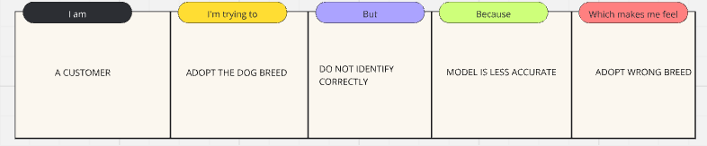
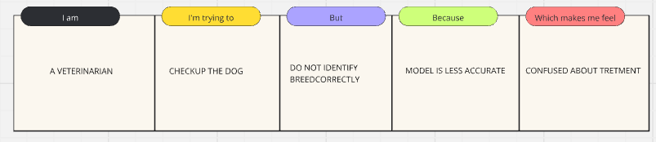

Problem Statement (PS) | I am (Customer) | I’m trying to | But | Because | Which makes me feel
PS-1 | Customer | Classify dog breed | Do not identify correctly | Model is less accurate | Prediction wrong
PS-2 | Veterinarian | Checkup the dog | Did not identify the dog breed correctly | Model is less accurate | Confused about Treatment

